Red telehandlers: LINDE expands its range of industrial and materials handling equipment through cooperation with SENNEBOGEN
With the SENNEBOGEN 360 G and 340 G, the Lower Bavarian machine manufacturer has successfully established its telehandlers in the demanding material handling sector since 2018. The next step will now follow at the international trade fair for intralogistics solutions LogiMAT from 11 - 13 March 2025 in Stuttgart, where the telehandlers will be presented to an international audience in the well-known LINDE design. In future, the LINDE branded models will be marketed under the product names LINDE YH40 and YH60. Both manufacturers agreed on this in a co-operation agreement.
Just as the green colour of SENNEBOGEN material handlers and cranes stands for leading machine technology in numerous industries worldwide, the same applies to LINDE's red forklifts, pallet stackers and vehicles in materials handling technology and industry. The telescopic handlers built by SENNEBOGEN are now being launched in Germany and Austria under the names LINDE YH40 / YH60, and other countries may follow.
As a manufacturer, SENNEBOGEN has not only been developing and selling the new Multi Line telehandler product line since 2018, but has also realised a new plant exclusively for these two products at the Bavarian site in Wackersdorf with the ideal cycle production for these products. SENNEBOGEN sells the 340 G and 360 G via its own dealer network, primarily in the recycling, port, sawmill and municipal sectors.
The SENNEBOGEN and LINDE telehandlers are characterised by their extremely robust design, high performance and the elevating cab, which has been unique for many years.
LINDE has extensive expertise and a very strong partner network in all areas of industry and materials handling technology. The cooperation between the two companies enables the network of LINDE sales partners to sell the telehandlers under the LINDE brand and product name in their traditional sectors, thereby significantly expanding the range of solutions for many industrial applications. At the same time, SENNEBOGEN is enhancing its comprehensive after-sales service with a suitable training programme so that customers can be served quickly and competently with their own service and spare parts supply. This great addition to the diverse product portfolio of materials handling technology opens up new opportunities for LINDE sales partners in market development. After a joint, lengthy start-up phase in which selected LINDE network partners were able to successfully place the green SENNEBOGEN telehandlers on the market, the official starting signal for the promising cooperation and the roll-out of the YH40 and YH 60 telehandlers in the red colour scheme will now be given at LogiMAT.

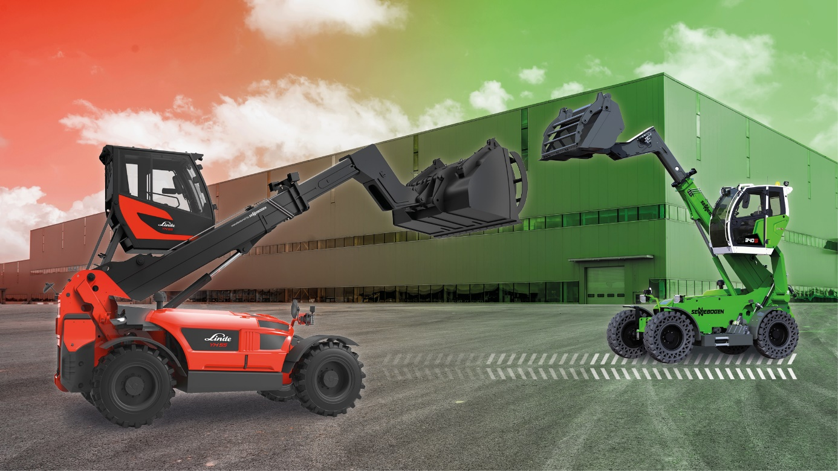
Captions:
Image 1: Now also in red: At LogiMAT in Stuttgart, SENNEBOGEN telehandlers will be presented to the public for the first time in the well-known LINDE colours under the names YH40 and YH60.
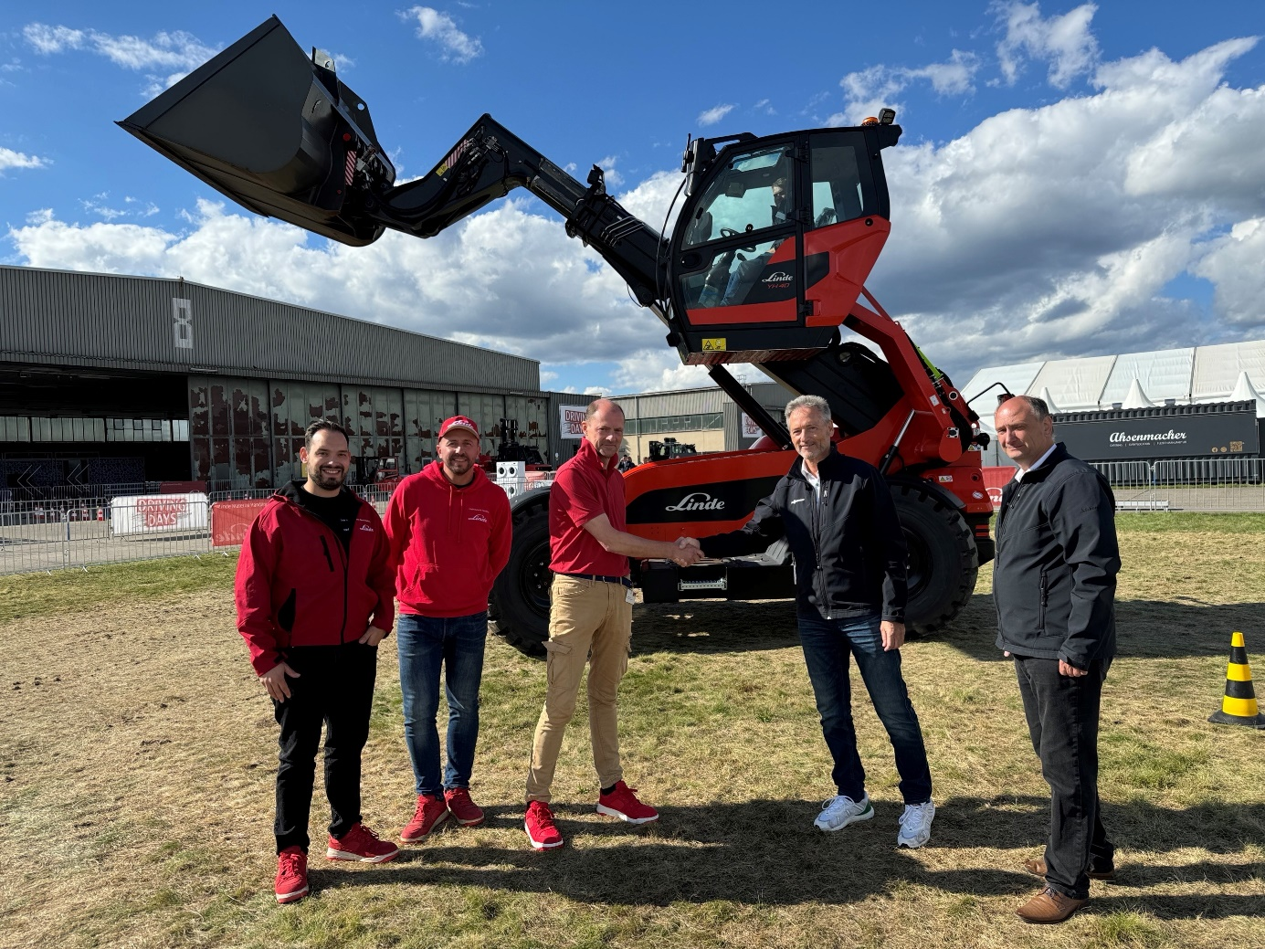
Image 2: Company representatives from LINDE and SENNEBOGEN jointly present the new telehandlers in the characteristic colour scheme.

